Web Integration done after the editing if the index.html file and successfully created the flask file app.py

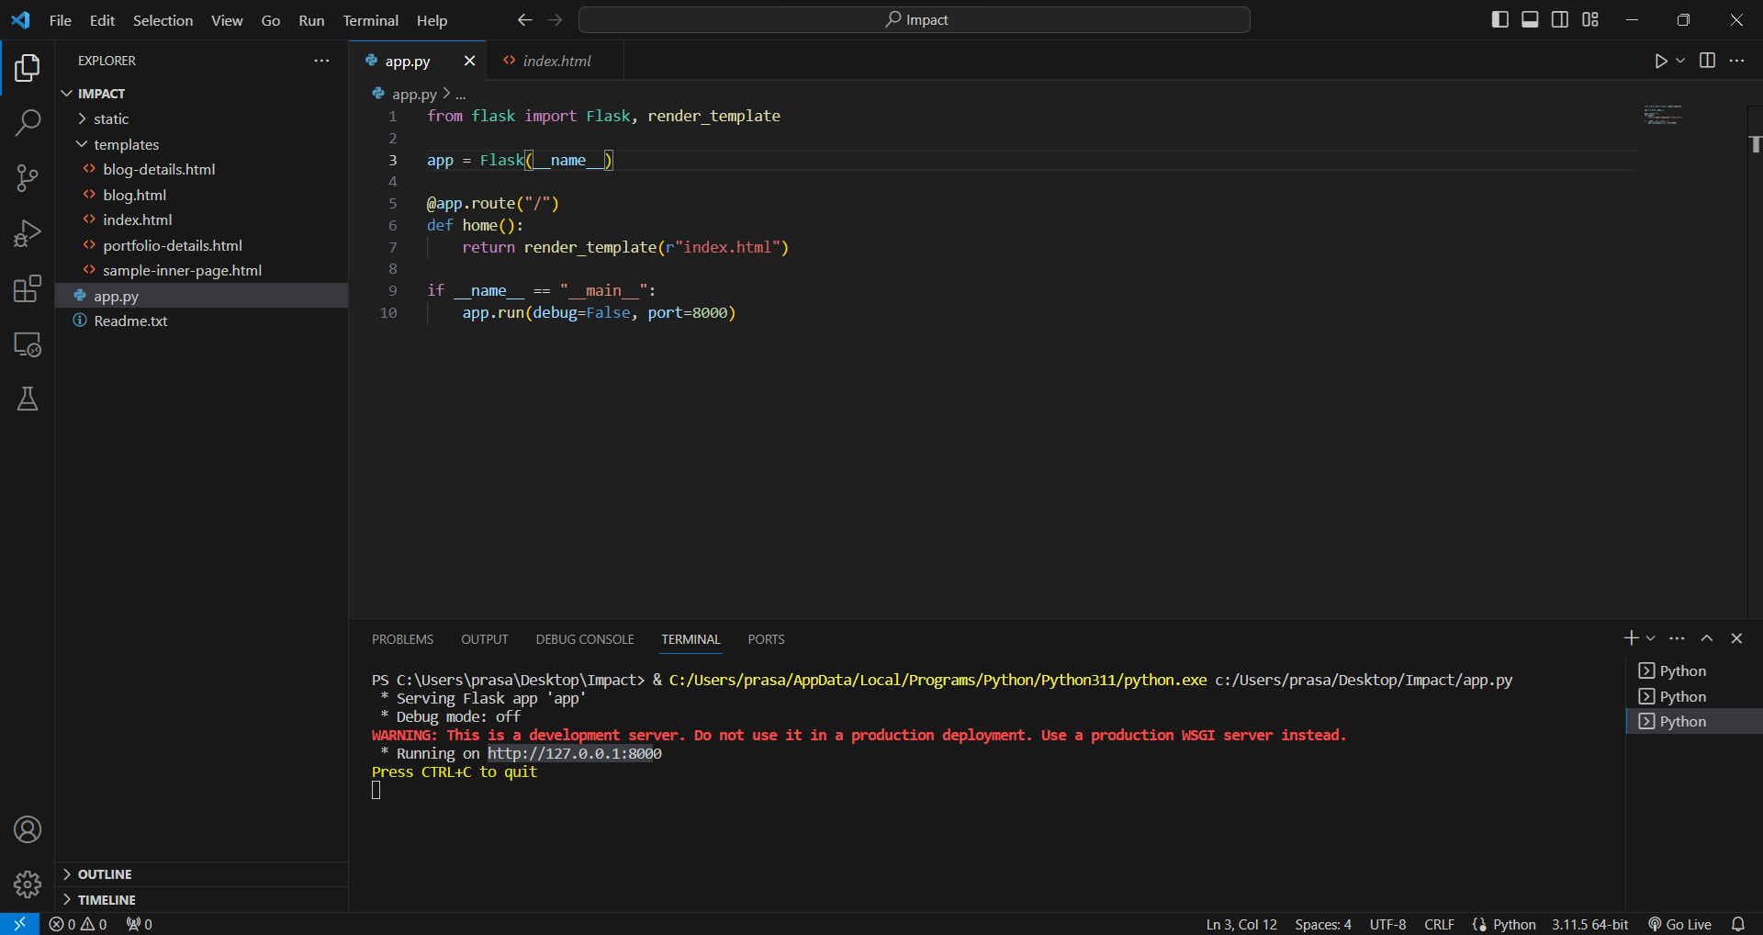

After successful running of the app.py file I got
http://127.0.0.1:8000

Used that url link in web browser, I got following website with my Dashboard, Story, and Report successfully.

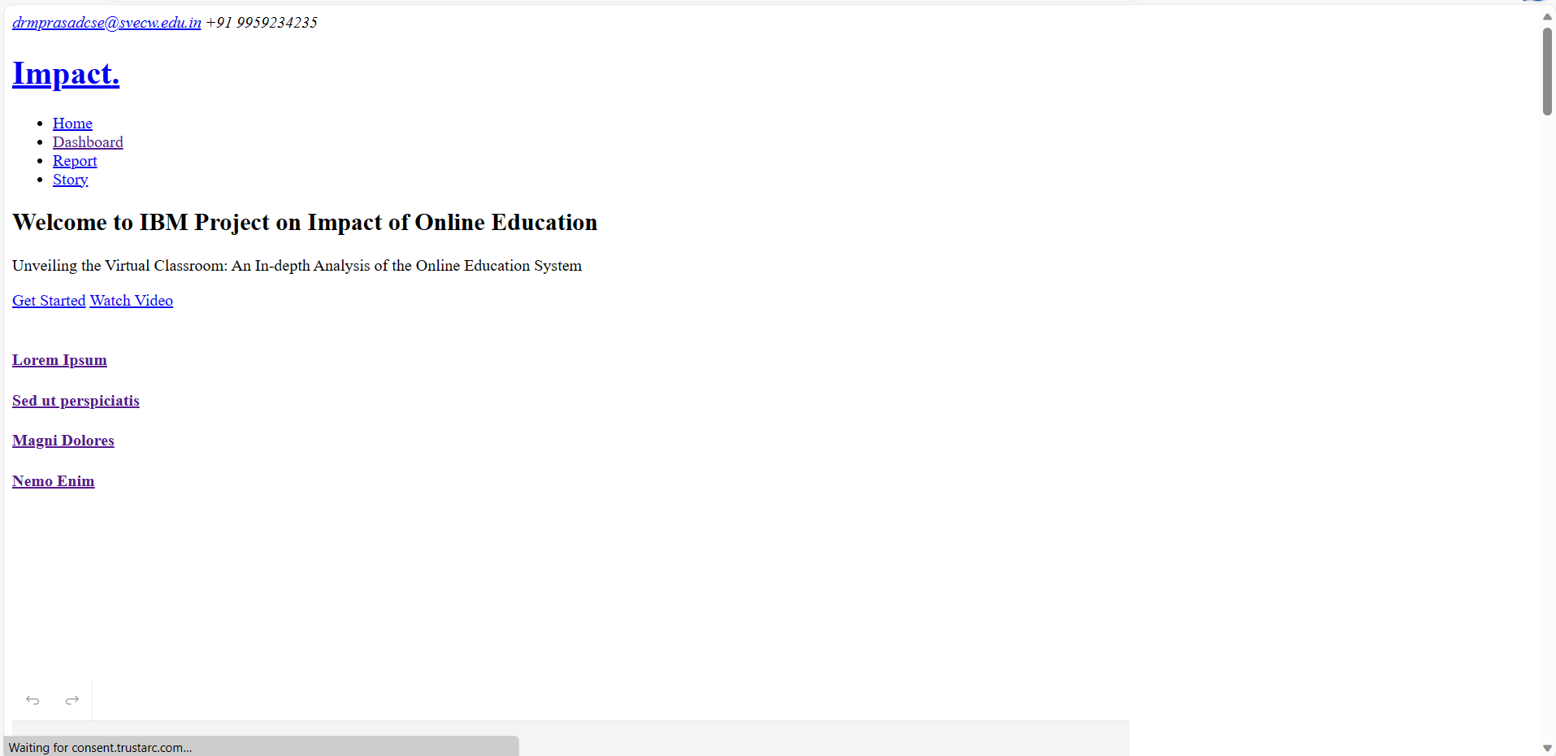

Dashboard:

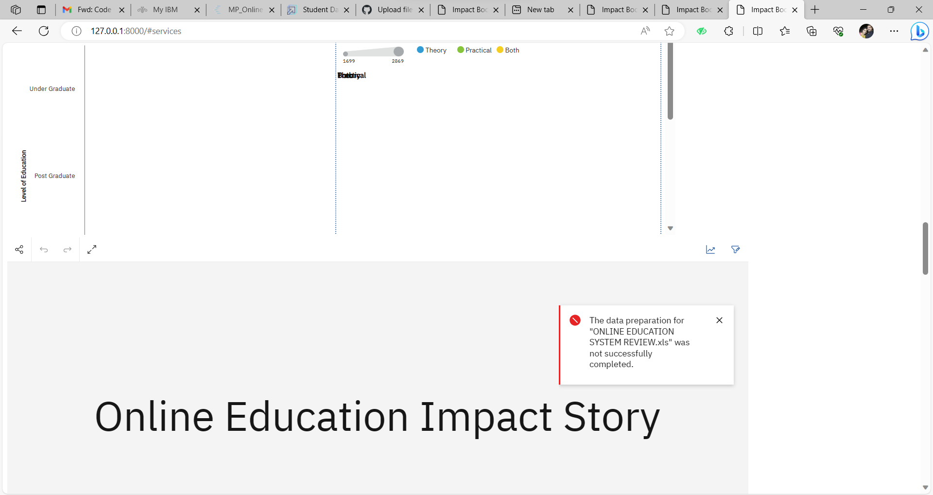

Report:

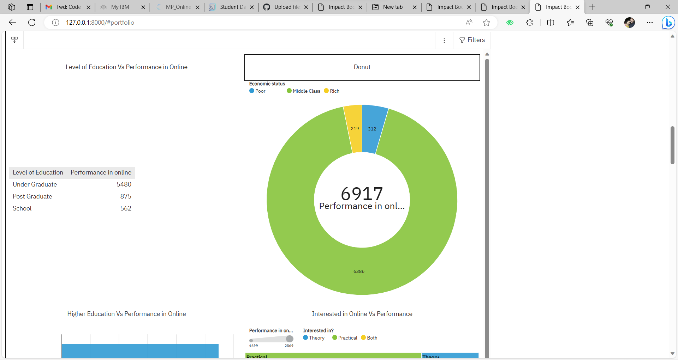

Story:

